**STAT 40001/STAT 59800 Statistical Computing Fall 2020**

**Lab-3**

1. Create the following matrix using R.



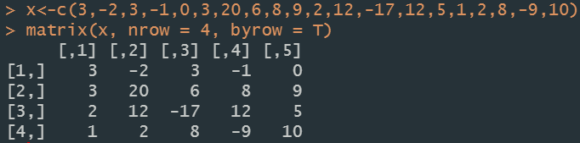

1. The data below contains missing values.

7,4,5,6,23,8,NA,34,23,56,NA,6,4,58,12,17,23, -10

1. Remove the missing values

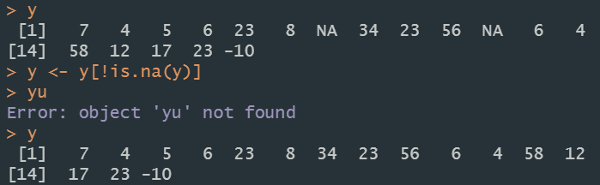

1. How many observations are less than 10?



1. Create a sequence of numbers from 1 to 10 and insert comma (,) using the R code >paste(data, collapse= “,”)

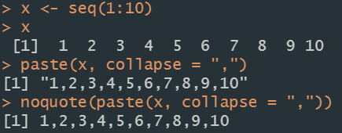

1. Consider the following two data sets:

|  |  |  |  |
| --- | --- | --- | --- |
| Name | Age | Major | Gender |
| Tony | 21 | Math | Male |
| Drew | 25 | Math | Male |
| Nancy | 27 | STAT | Female |

|  |  |  |  |
| --- | --- | --- | --- |
| Name | Age | Major | Gender |
| Jay | 23 | CS | Male |
| Amanda | 28 | Math | Female |
| George | 27 | STAT | Male |

1. Create two different data frames from the above observations and convert them to a single data frame.

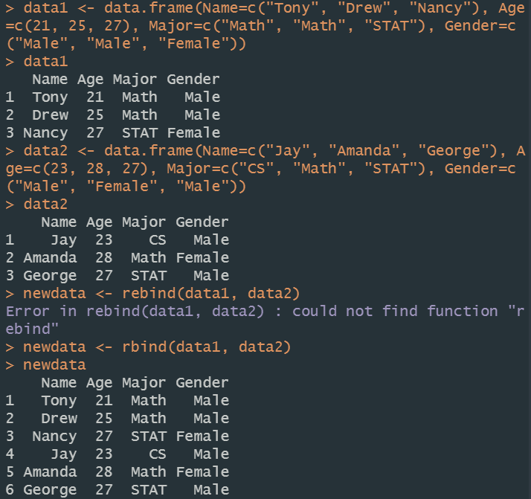

1. Sort the new data frame using Age.

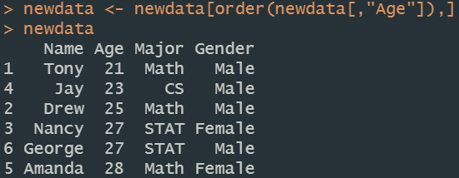

1. If then calculate A+B and A-B.

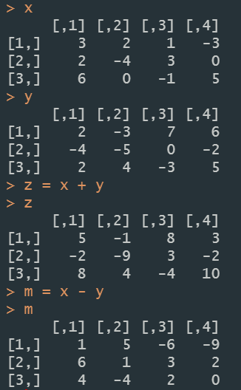

1. Using the matrix method, solve:

3*x* – *y* = 5

-4*x* + 2*y* = -9.

